BAHRIA UNIVERSITY, ISLAMABAD
Department of Computer Science



INTRODUCTION TO DATA SCIENCE LAB

─────────────────────────────

LAB JOURNAL # 03

─────────────────────────────

SUBMITTED BY  Umm-e-Habiba Imran  01-134241-048  6TH A | SUBMITTED TO  Maryam Aslam  Fall 2026  17th September, 2026

Task 1
import requests
from bs4 import BeautifulSoup
import pandas as pd
url = "https://books.toscrape.com/catalogue/page-1.html"
response = requests.get(url)
response = response.content
soup = BeautifulSoup(response, 'html.parser')
books = []
ol = soup.find('ol')
articles = ol.find_all('article', class_='product_pod')
for article in articles:
titles = article.find('img')
titles = titles.attrs['alt']
star = article.find('p')
star = star['class'][1]
price = article.find('p', class_='price_color').text
image = article.find('img')
image_url = image["src"]
books.append([titles, star, price, image_url])
df = pd.DataFrame(books, columns=['title', 'rating', 'price', 'image_url'])
print(df)
df.to_csv('books.csv', index=False)

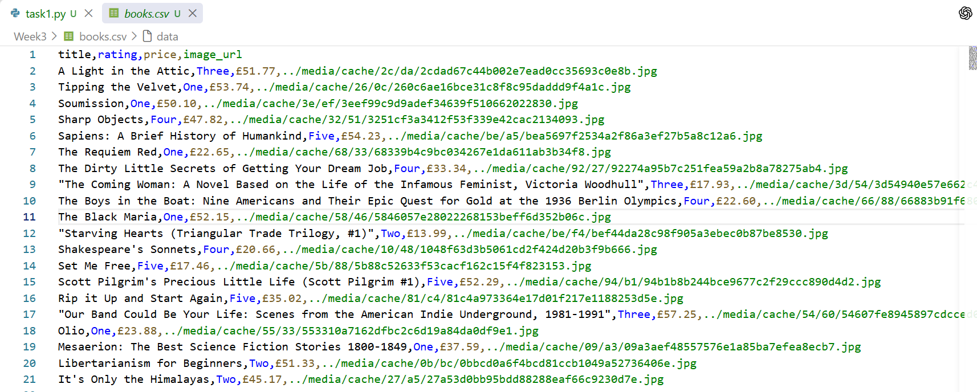

Task 2
import requests
from bs4 import BeautifulSoup
import pandas as pd
url = "https://www.bahria.edu.pk/page/PageTemplate4?pageContentId=4603&WebsiteID=5"
response = requests.get(url)
response = response.content
soup = BeautifulSoup(response, 'html.parser')
teachers = []
tables = soup.find_all('table')
for table in tables:
rows = table.find_all('tr')
for row in rows:
cols = row.find_all('td')
if len(cols) == 2:
name = cols[0].text.strip()
designation = cols[1].text.strip()
print(name, designation)
teachers.append([name, designation])
df = pd.DataFrame(teachers)
df.to_csv('teachers.csv')

